Concept Pitch Document

Title

Language of Spells

Genre

Word search / role play game

Story (200 words max)

The story is about a teenage girl Manila that flees with her family from the war in her country.
Manila hopes to find peace in her new home country and fulfil her dream of becoming a spell writer. But the road is long and dangerous. Her new home country isn’t as peaceful as she thought it would be. War seems to follow her everywhere she goes.
Will Manila find peace, learn to write, read and cast spells?

Game mechanics (400 words max)

The game is a combination of certain game genres. The puzzles (fights/adventures) are a combination of word search and “puzzles and dragons”
The player can move letters in order to make words. Making the right words will activate a spell/action.
The player will be rewarded with resources after each adventure and can use these resources to upgrade spells and settlements like most role play games.

Aesthetics (200 words max)

2D from an angle and low detailed art style. 3D game characters.
The art is layer based.
To much detail will do more harm then good. Fantasy stories and books go hand in hand. Using water paint might add up to the theme of the game.

Marketing and research

The overall BOI score is 26. That’s high!

Utility
The game contains a lite version so that players can try the basic game.
Players can relive their favorite story or discover new stories of their favorite books.
Part of the money can go to charity?

Price
3$/€ for the basic game and 3 or 4 $/€ for an expansion is acceptable. The players know that there is certain IP behind the expansions. Selling the expansion for the same amount as the basic game is there for accepted.

Costs
Translation costs can be a problem. English, Dutch and French will be no problem though. Maybe it’s possible to ask players for help?
Depending on the situation of the participants, part of the production and pre-production can be done voluntarily. We can also go to VAF for funding the development.
Is charity possible?

Adoption
We should make a clear and good business deal before the production starts. Do we give ourselves earnings or do we simply get a part of the revenue?

Non customers
Current market + tier 1: Word search players (puzzle gamers)
Tier 2: Role play gamers
Tier 3: Casual gamers

Commonalities are based on the player motivation model. 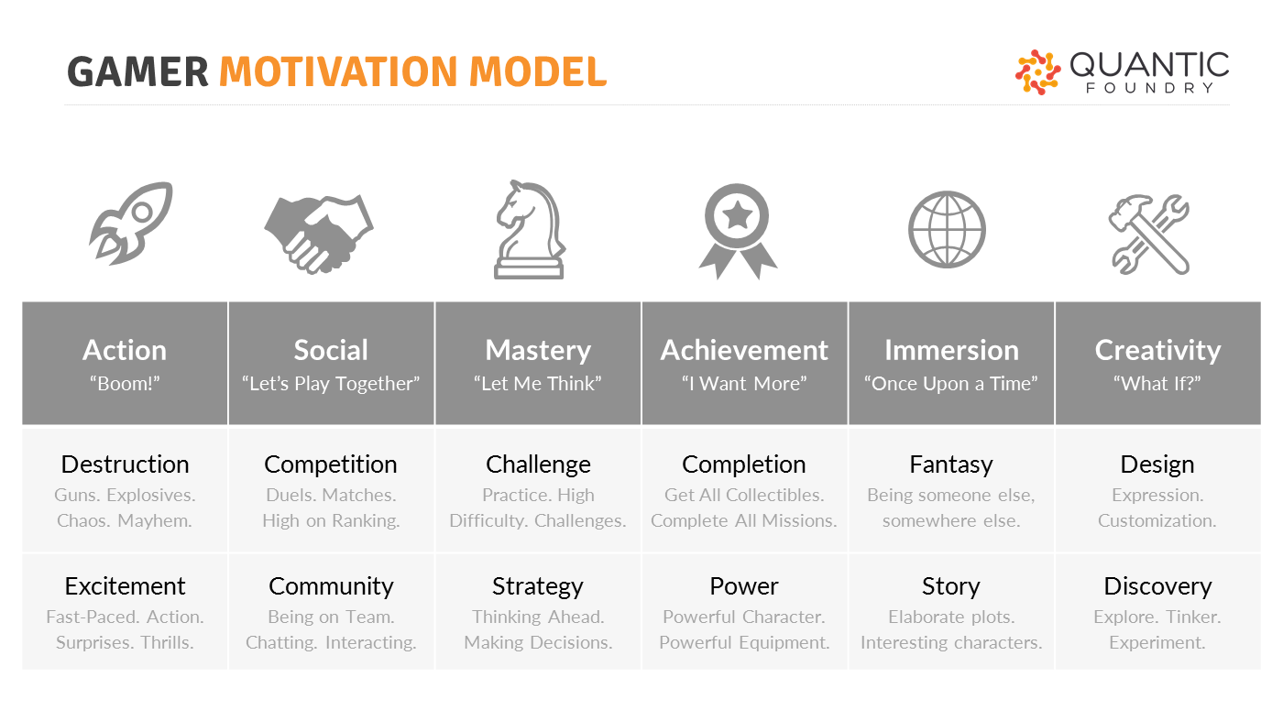
Common interests of puzzle, casual and rpg players:
Mastery: Challenge
Achievement: Completion
Social: Competition
Social: Community => teamwork only

ERRC / 4 action framework compared to classic RP games
Erase: | Raise:
(Design: Customization) Only 1 character with 1 outfit.  (Achievement: Equipment) No equipment, just spells. | (Achievement: Completion) Upgrade and complete buildings and constructions.  (Mastery: Challenge) Battles are replaced with challenging puzzles.  Social: Co-op
Reduce: | Create:
(Immersion: Story)  (Creativity: Discovery) No open world. Limited access to other places.  (Mastery: Strategy) Less strategy is needed in the game. Battles are replaced with puzzles. | (Mastery: Challenge) New puzzle mechanics.

Strategy canvas
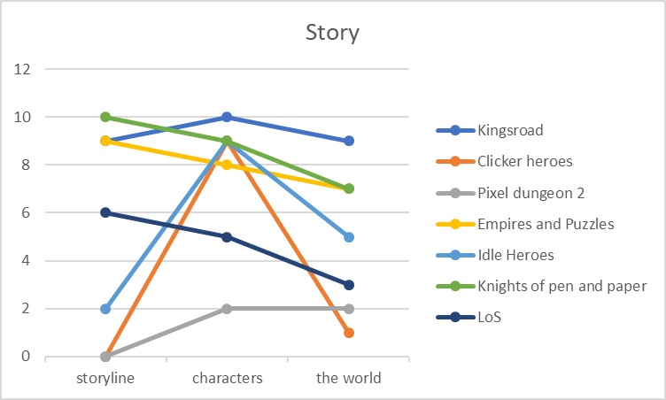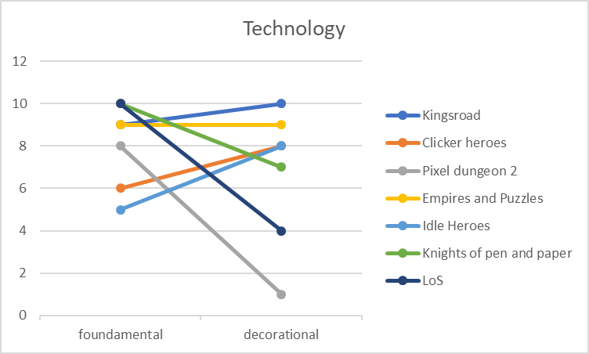
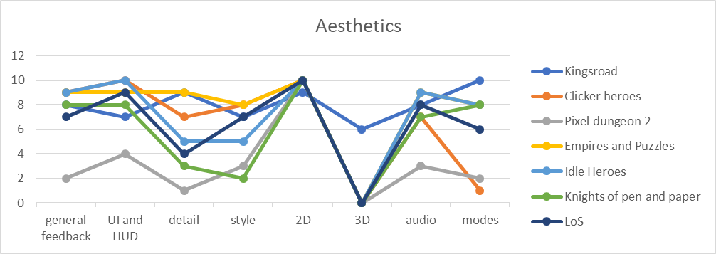
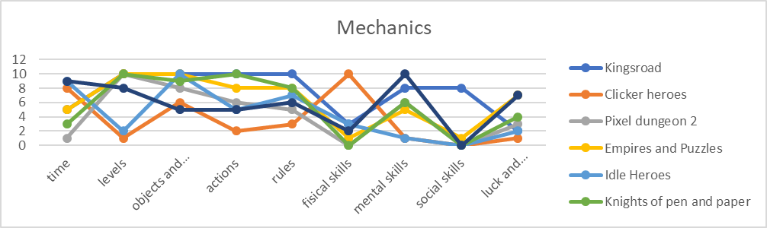
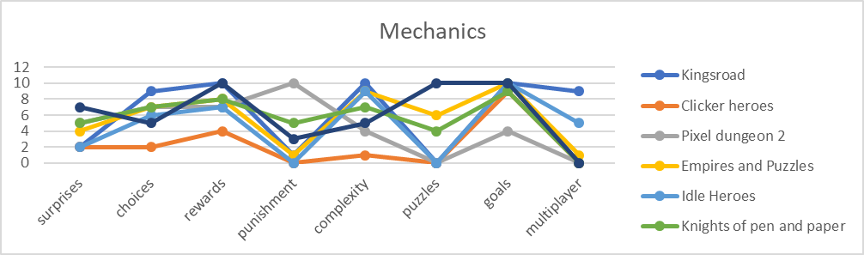

6 Paths framework
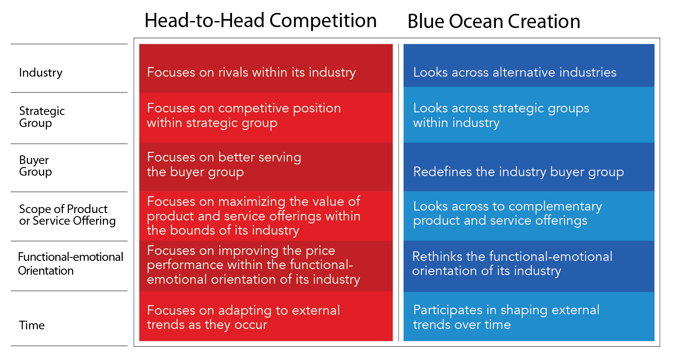
Industry:
Books and comics industry.

Strategic groups:
Rpg and Word search genres.

Buyer group:
Focusing on buyers and influencers. (Chase the non-payers, not the whales.)

Scope of product:
Everybody has a smartphone.

Functional-emotional orientation:
Charity?

Time:
?

Main business model

There is a bunch of research behind the monetization strategy. We focus on the conversion of all players, not just the whales.
For more info:
http://vangoidsenhoven.weebly.com/game-dev-blog/cro-part-3-i-love-it-when-a-plan-comes-together

Monetization model: premium and lite / F2P
Lite / F2P: ads and selling upgrades and extra characters
Premium: selling the basic game (without restrictions) and selling expansions

Risks and advantages

USP:
- Unique art style
- Unique gameplay mechanics
- Stories that is well know in our own world.

Risks:
- A level editor must be build to make all scenarios and expansions.
- A lot of stories means a lot of text and more translation costs.

Art and inspiration


